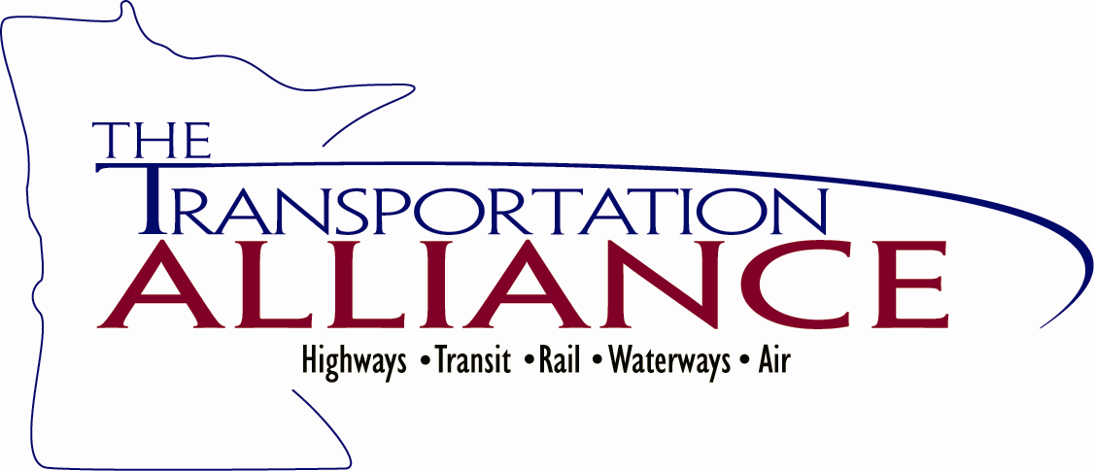


Transportation Day at the Capitol

Thursday, February 23, 2012

Kelly Inn ~ Saint Paul

9:30 AM – 3:30 AM

Register at: www.transportationalliance.com

Join us for the biggest transportation advocacy event of the
2012 Session!

Transportation Day at the Capitol is a great opportunity for you to meet with your legislators to discuss critical issues in transportation.

2012 is the Capital Bonding Year.
Join your colleagues from around the state in advocating for additional funding for Local Bridges, Local Roads, Transitways and Transit Facilities, Port improvements, and Rail projects.
Hear the latest news directly from key legislators.
Support transportation investments to create jobs and assist our economic recovery.
We’re here to make it easy for you to make a difference in transportation funding.
~Alliance staff will be arranging individual meetings for you.
Please contact Kathy Jensen at (651) 659-0804 or kathy@transportationalliance.com
with any questions.

Since 1893
525 Park St., Ste. 240  Saint Paul, MN 55103  651/659-0804  Fax 651/659-9009 12/9/2012
Email: kathy@transportationalliance.com  www.transportationalliance.com

